Contents

Fishr outline 2

Features to add 2

Fish Detail Uploader 2

Chat Client 2

Chat Client 3

Chat Server 3

Chat Rest API 3

WebSocket Server 3

Media Storage 3

Database structure for user interaction 3

User registration and login 4

Registration of user 4

User login 4

Website Font-End 6

Main page design 6

Always shown 6

When logged in 6

When logged out 6

# Fishr outline

Go ahead, give me a look…

Fishr is an instant messaging, image sharing app designed to allow fishermen to share their catches and record all the tides weather water temp location gear and bait that was used for their future use.

Will utilize the fish scraper app when running on the server.

**Premium feature gives clues to where to find fish?**

## Features to add

1. Automatic fishscraper to log all information
   1. For the added websites keep scaped information for 1-2 months perhaps, so that fishing trips can be added within a reasonable period

# Fish Detail Uploader

For each fishing trip upload the number caught and their sizes. Will use the Web Scraping python app to find conditions that they were caught in. This *might require making a backup of the fishing conditions* that are shown on the internet as the websites possibly clear the information afterwards.

1. Fisherman will confirm time and date of fishing trip
2. Fisherman will input number of fish of each type
3. Option to record sizes/weights of good fish if desired
4. Upload photo for reference
5. Any notes to keep
6. Compare all info for a day of fishing, show best out of favorite places

*Webserver*

1. Webserver will then put in time and date
2. Webserver will use backed up weather and swell information for that time and date

Will start with the webserver side

# Chat Client

Encryption, encryption encryption…

*From comet chat*

## Chat Client

One required for PC via website and one required for Android at a minimum. Planning on using PHP for website and Java for the app.

## Chat Server

Hosts software, frameworks and databases for chat. Receives message, identify it’s recipient/s, queuing the message then forwarding it on.

This will use the C# Programming language. It will utilize socket programming.

https://www.geeksforgeeks.org/socket-programming-in-c-sharp/

## Chat Rest API

## WebSocket Server

## Media Storage

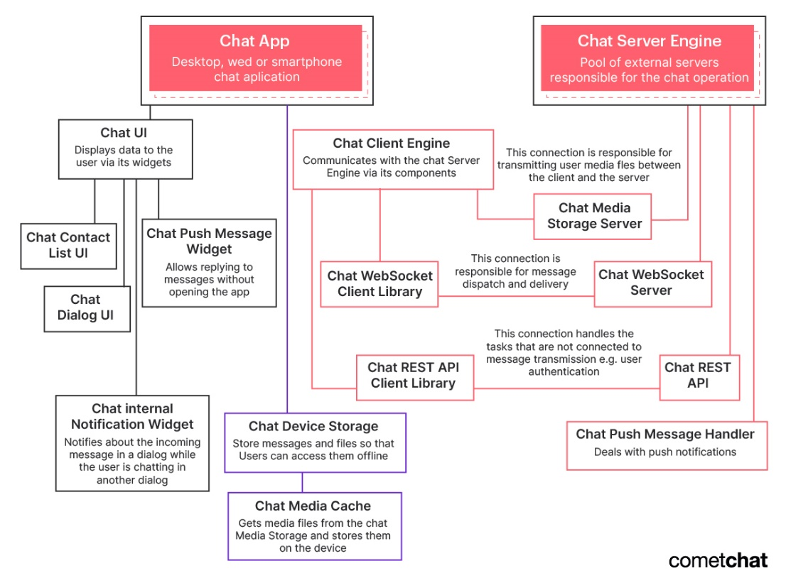

## Database structure for user interaction

Below is a series of tables to be created for the Fishr webpage to work.

* Users
* User Posts
* User Friends/Blocks
* Need instant message research

# User registration and login

All users kept in the User table. Full name, email, Username, hashed password and country is saved in this database for all the users.

## Registration of user

This is a simplified extract for the method used in the webpage - [*https://www.tutorialrepublic.com/php-tutorial/php-mysql-login-system.php*](https://www.tutorialrepublic.com/php-tutorial/php-mysql-login-system.php)*.*

1. Use a mysqlphp config file to connect to the database.
   1. Will use the login fishrwebsite to access the fishr database.
2. Define and clear all variables and errors
3. Check the request method is POST
4. Validate username and add username
   1. Check Username Exists --------- low priority as the fields are set to required….
   2. Contains correct characters--------- low priority will add later….
   3. Check if username is free
   4. If all checks pass, add username
5. Validate passwords
   1. Check password field is not empty
   2. Minimum password length
   3. Confirm both passwords match
6. Add password to database as hash
   1. Check that no password errors exist
   2. Prepare input statement for inputting password into database
   3. Hash password using password_hash( ) function
   4. Execute mysql command
7. Replicate step 3 for email and country
8. Replicate step 3 for full name
   1. Split the name into first and last name
9. Close connection

## User login

This is a simplified extract for the method used in the webpage - [*https://www.tutorialrepublic.com/php-tutorial/php-mysql-login-system.php*](https://www.tutorialrepublic.com/php-tutorial/php-mysql-login-system.php)*.*

1. Session_start( )
2. Check if user is already logged in
   1. Redirect to welcome page is already logged in
3. Use a mysqlphp config file to connect to the database.
   1. Will use the login fishrwebsite to access the fishr database.
4. Define and clear all variables and errors
5. Series of checks
   1. Request method is POST
   2. Username and Password not empty
6. Prepare mysql statement
7. Execute the statement using username and hashed_password

# Website Layout

## Main page design

### Always shown

* Most popular fishing spots
* Bottom of page - a jumping fish with all that website footer stuff that is needed

### When logged in

* Log out button
* User control panel button
* Add a fishing trip
* Messages
* Users favorited fishing spots for next 3 days
* Last few fishing trips
* Upcoming promising looking days from users fishing history
* Latest posts from friends
* Fishing request from friends
* If any friends are wanting to go fishing this weekend

### When logged out

* Log in button
* Make account

# Database Structure

# Fish Scraper – getting information from other websites

To have everything in one place…

Workings of Fish Scraper

*User inputs:*

* Location of fishing
* Date to go fishing
  + Time as well, but not required
  + Possibly multiple dates
* Characteristics of what is deemed a good fishing day
  + Max wave height/power
  + Max wind
  + temperature

*Websites to add:*

1. Surf Forecast
2. Met Service
3. Fishing Net
4. Tides4Fishing

The above web sites are scraped for the location of interest. This will involve searching in the websites for the correct location, and returning information found which suits the time frame listed

## Incorporation into Fishr site

The Fishr site will use this program in two scenarios

1. When user requires to see the upcoming weather/swell/tides for a particular day or set of days over the next week or so
2. Backup past fishing weather every few hours but only for locations which have previously been added to users’ favorites.
   1. How to save information for best access
   2. Best way to access information for website
   3. Only keep weather data that has been

The data is to be input into a JSON file and then stored in mySQL for easy access in future. These files will be split into days, with all data from all websites lumped into them.

* Have hourly data stored in the JSON file?